**Option B**

1. *Using the four-factor model discussed in Chapter 28 of Mathletics, determine where we ranked in the NBA last season and how we currently stack up so far this season. Briefly describe where we are deficient and where we excel.*

The data collected comes from Basketball-Reference.com and contains data from the 2023-2024 season for all 30 teams. The data set includes metrics that most contribute to winning such as the four factors Effective Field Goal Percentage (eFG%), Turnover Ratio (TOV%), Rebound Percentage (ORB%), and Free Throw Rate (FTR).

With the data set collected from Basketball-Reference, some filtering needed to be completed. Removing values not used in the analysis was key as well as updating the values to all be in the same format. Also, the columns needed to be renamed as there were many symbols and labels such as “%” that caused issues when attempting to analyze.

The offensive four factors analyzed included metrics such as Offensive Effective Field Goal Percentage (Off_eFG_Pct), Offensive Turnover Percentage (Off_TOV_Pct), Offensive Rebound Percentage (Off_ORB_Pct), and Offensive Free Throw Rate (Off_FTR).

The defensive four factors analyzed included Defensive Effective Field Goal Percentage (Def_eFG_Pct), Defensive Turnover Percentage (Def_TOV_Pct), Defensive Rebound Percentage (Def_DRB_Pct), and Defensive Free Throw Rate (Def_FTR). The Houston Rockets 2023-2024 statistics in those categories are shown in the table below.

|  |  |  |
| --- | --- | --- |
| **Category** | **Value** | **Rank** |
| **Off_eFG_Pct** | 0.529 | 26 |
| **Off_TOV_Pct** | 0.112 | 4 |
| **Off_ORB_Pct** | 0.251 | 10 |
| **Off_FTR** | 0.199 | 12 |
| **Def_eFG_Pct** | 0.533 | 5 |
| **Def_TOV_Pct** | 0.122 | 15 |
| **Def_DRB_Pct** | 0.76 | 15 |
| **Def_FTR** | 0.219 | 28 |

Offensively the Houston Rockets shot the ball poorly, ranking towards the bottom of the league in effective field goal percentage. They had success when turning other teams over and were in the middle of the pack when it came to rebounding and free throw rate. Defensively the Rockets played well when it came to limiting opponents’ effective field goal percentage, ranking in the top 5. They were average in turning team over and grabbing defensive boards but performed very poorly when keeping teams off the foul line.

For a more comprehensive look at teams’ overall performance, we calculated the difference of the offensive and defensive metrics of the four factors. A correlation was calculated using the differential metrics along with team wins. It showed that the differential eFG% had the highest positive correlation with wins (0.89). This makes it the most important metric when determining which teams will be successful. When it came to TOV%, a moderate negative correlation (-0.39) was seen. This suggests that having less turnovers than your opponent tends to lead to more wins. ORB% had a weaker negative correlation with the outcome of a game (-0.12) making it less significant than the other metrics. Finally, FTR had a moderate positive correlation (0.39), highlighting that free throws are important when trying to win a game.

The table below shows the Southwest division and how the teams rank based on their differential metrics. Based on these league wide ranks, the Rockets have a mixture of strengths and weaknesses when compared to the rest of the division. They excel at turnover differential but not when it comes to offensive rebounding and free throw rate. The average eFG%, which had the strongest correlation with winning, highlights the need to improve team shooting when compared to the division and the entire NBA. The Rockets are ranked 20th when it comes to team offensive rating, which accounts for points scored per 100 possessions. They rank behind division rivals Dallas and New Orleans, proving again that bolstering the offensive production should be addressed in the offseason. Improving their ability to score efficiently should also help the team get to the line more and elevate their poor FTR.

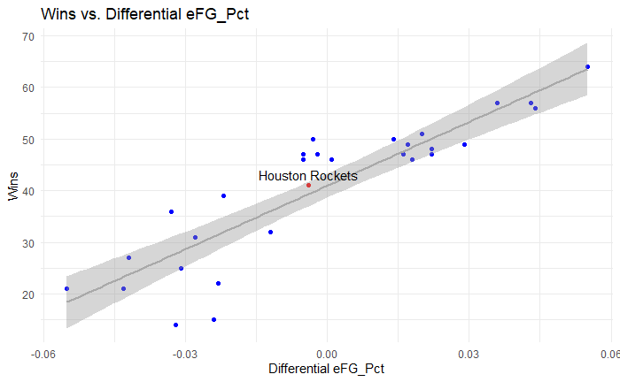

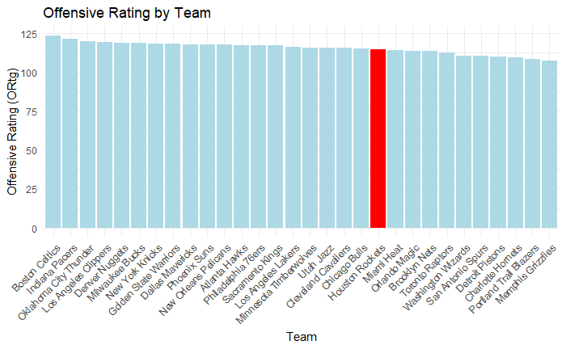

1. *Looking at page 255 (Figure 28.4) in Mathletics, conduct a similar analysis that determines the relative importance of each of the four factors. Based on your findings, how many games should we have won last year?*

A multiple linear regression analysis was performed to conduct a similar analysis to the one from *Mathletics*. This method determines the relative importance of each of the four factors in predicting the number of wins for each team. It is a similar method because it is aimed to gain insights on what metrics contribute to success in the NBA. The differential metrics of the four factors were calculated by the difference in a teams’ offensive and defensive performance. The metrics included Effective Field Goal Percentage Differential (Diff_eFG_Pct), Turnover Percentage Differential (Diff_TOV_Pct), Offensive Rebound Percentage Differential (Diff_ORB_Pct), and Free Throw Rate Differential (Diff_FTR). The regression model used those differential metrics as the independent variables and number of wins (W) as the dependent variable. The equation generated from this analysis was:

***Wins = 89.15 + 381.82 (Diff_eFG_Pct) − 334.59(Diff_TOV_Pct) + 93.43(Diff_ORB_Pct) + 106.05(Diff_FTR)***

The coefficient for effective field goal percentage differential was 381.82 meaning a 1% increase would lead to an average of 3.82 more wins. This is the most significant factor and it explains why shooting efficiency is so crucial in the NBA. Turnover percentage differential had a -334.59 coefficient indicating that a 1% decrease would add around 3.35 wins. The differential metrics of offensive rebounding percentage and free throw rate had a less significant impact than the other factors. Their coefficients were 93.43 and 106.05 respectively. This shows that shooting efficiency and managing turnovers are the two most influential factors for winning games.

The Houston Rockets won 41 games last season and this model predicted 41.29 wins. The model was reliable for accurately predicting the Rockets win total as there was a very small residual value (-0.29). The model had a multiple R-squared value of 0.9176 and an Adjusted R-square of 0.9044 indicating that the four factors explain almost 92% of the variance in win totals. This further proves the model’s strong predictive ability. Below is a residual plot created for the entire league.

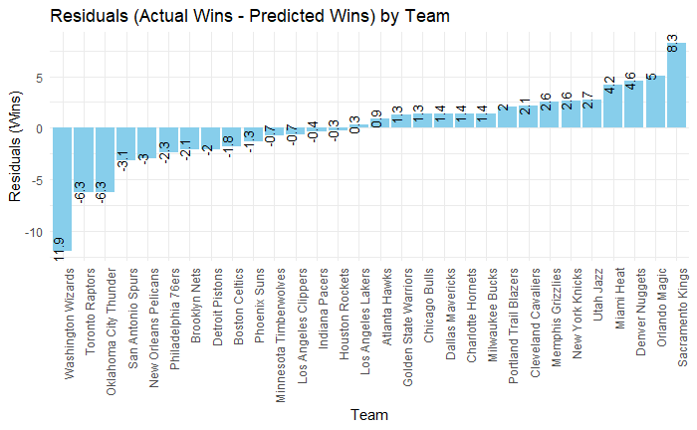

1. *Using historical data, determine a new classification framework for identifying player types. Provide a description of each player type based on the metrics that you select.*

The dataset collected for this analysis includes player statistics from the 2023-2024 NBA season. It contains basic player information (i.e. Player name, team, and position) and important per game stats (i.e. points, assists, rebounds, steals, blocks, and effective field goal percentage). To prepare the data for analysis, proper cleaning and filtering methods were completed. Irrelevant columns like player rank and any rows with missing values were removed. Columns were selected based on player classifications that were relevant to the analysis (Player, Pos, Tm, PTS, AST, TRB, STL, BLK, and eFG_Pct). The dataset included multiple entries for players who played on different teams during the season. These players’ statistics were aggregated by summing the relevant metrics.

To classify players into distinct types based on their performance metrics, this analysis used K-means clustering. This popular machine learning algorithm groups players into clusters based on similar statistical profiles. This method is commonly used in sports analytics to classify players based on skill type such as scorer, defender, or role player. Implementing this method started with standardizing performance metrics so that all of the variables would have an equal contribution to the clustering process. NBA players are typically categorized into five broad types so that’s how many clusters were used during the K-means clustering. This allows coaches and management to better understand the roles of each player on the roster. These insights can be used to assist in rotation strategy, roster makeup, and player development.

Visuals were created to show the distribution of players across different clusters (each represented by a different color) based on performance metrics. The first scatter plot shows the relationship between points per game and assists per game, highlighting their ability to score and make plays. Cluster 3 (Green) stands out as it likely represents key offensive players who can score or run the offense. Cluster 4 (Blue) looks to be solid contributors on the offensive end as well. The fact that there is a high concentration of players in the lower left quadrants further indicates the significant impact cluster 3 players have on the game.

The second scatter plot showing the relationship between rebounds and blocks per game gives insights into a player’s defensive contributions. Players in cluster 5 (Pink) excel here suggesting they are likely big men who anchor the defense. Cluster 4 (Blue) has an impact on the defensive end as well giving further insight into their supporting role. Cluster 3 (Green) proves to be the all-around star players as they continue to excel in each visual.

The bar graph is an excellent representation of all of the clusters, giving a clearer representation of player types. Below are the takeaways about each cluster and the types of roles they play for their team.

**Cluster 1 (Red):** These players have lower average value metrics across every metric except for eFG%. This suggests that these are bench players who get limited minutes.

**Cluster 2 (Yellow):** Players in this cluster performed the worst in every metric analyzed. These players do not make contributions on either side of the floor indicating they are likely replacement candidates.

**Cluster 3 (Green):** These players perform well across the board. They are the all-around star players that contribute on both ends of the court, making them extremely valuable to a team.

**Cluster 4 (Blue):** They have a solid contribution offensively and are good at forcing turnovers. This suggests a “3-and-D” guard or wing player who shoot well and play strong perimeter defense.

**Cluster 5 (Pink):** These are likely big men who protect the rim and grab rebounds. They have the best eFG% which shows they take many high-percentage shots around the rim such as layups, dunks, and putbacks.

1. *Determine the types of players that currently make up our roster. Is there a particular type of player that we are lacking, or do we have multiple types of players that should be adjusted? What type of player(s) should we look to add this offseason either through free agency or the draft? Tie in your answers from 1 and 2 above.*

The Houston Rockets roster consists of an abundance of young players with a lot of potential. This is due to consistently drafting in the top 5 over the past few years. Adding veterans and a proven coach last offseason allows for more insights on how to approach the current offseason. The young core of this roster consists of Jalen Green (an athletic guard with a score first mentality), Alperen Sengun (a versatile playmaking big man who took a big step last season), Jabari Smith Jr. (a modern big man who can stretch the floor and defend well), and Amen Thompson (who made pleasantly surprising impacts as a rookie last season). These four are joined by young athletic players that provide instant offense off the bench such as Tari Eason and Cam Whitmore. The veterans acquired last offseason to bring structure and toughness to the team were Fred Van Vleet and Dillon Brooks. Both can shoot well and play tough defense while Van Vleet also runs the offense. While this team has a lot of talent, there needs to be more consistent defensive effort and shot making. Adding an elite shooter in the draft like Reed Sheppard was crucial for a team that was in the bottom third of the league in three-point percentage. Player development has to be the most important factor during this offseason. The roster has many young players that would benefit greatly by having a clear role they could excel in. Trading a young asset for a proven veteran would also help the Rockets to be more consistent. A player like Jalen Green who is flashy and has a lot of upside, may be expendable based on his inability to defend. Swapping him for an all-star caliber veteran could help the team find an identity on both ends of the floor. Alternatively acquiring a big man could help with rebounding and defense. Having a big to extend plays and get second chances is vital to the success of a team.



